**PROJECT PROPOSAL: AUTONOMOUS OBSTACLE-AVOIDANCE AND LINE TRACKING CAR WITH FREERTOS**

# PROJECT OVERVIEW

We propose the development of an autonomous car capable of detecting obstacles and tracking lines using ultrasonic sensors and infrared sensors and managing tasks efficiently with FreeRTOS. The car will use a combination of components including ultrasonic sensors, L293D motor driver, LCD display, infrared sensors, and servo motor to create a functional and efficient obstacle-avoidance and line-tracking system.

# OBJECTIVES

**The primary objectives of this project are to design, build, and demonstrate an autonomous car that can:**

1. Detect obstacles using ultrasonic sensors.
2. Analyze sensor data and make real-time decisions to change direction.
3. Implement motor control using the L293D motor driver.
4. Display the car's current direction on an LCD screen.
5. Utilize a servo motor for ultrasonic scanning within a 180° range.
6. Implement line tracking using infrared sensors.
7. Manage tasks efficiently with FreeRTOS for multitasking and real-time operation.

# COMPONENTS AND MATERIALS

* Ultrasonic HC-SR04 sensor: To detect obstacles in the car's path.
* Servo motor: For scanning the environment using the ultrasonic sensor.
* L293D motor driver: To control the speed and direction of the car's motors.
* Motors: To drive the car's wheels.
* Caster wheel: To provide stability to the car's chassis.
* Chassis: The framework to hold all components securely.
* Infrared sensors: For line tracking.
* Microcontroller compatible with FreeRTOS.

# PROJECT IMPLEMENTATION

1. Hardware Assembly: Assemble the chassis, attach the motors, and mount the caster wheel.
2. Ultrasonic Sensor Integration: Connect the ultrasonic sensor to the servo motor axis for scanning.
3. Motor Control: Integrate the L293D motor driver to control the car's movement.
4. LCD Integration: Connect the LCD display to show the car's current direction.
5. Software Development: Develop software to read ultrasonic sensor data, analyze it, control the motors, and implement line tracking.
6. Scanning Algorithm: Design an algorithm for the servo motor to scan the environment using the ultrasonic sensor.
7. Line Tracking Algorithm: Implement a line tracking algorithm using infrared sensors.
8. FreeRTOS Integration: Configure and integrate FreeRTOS for efficient multitasking and real-time control.
9. Testing and Calibration: Test the car's obstacle detection, avoidance, and line tracking capabilities. Calibrate the system for optimal performance.
10. Fine-tuning: Adjust parameters and algorithms to enhance the car's responsiveness and accuracy.

# EXPECTED OUTCOMES:

**Upon successful completion of the project, we anticipate achieving the following outcomes:**

1. A functional autonomous car capable of detecting obstacles, changing direction to avoid them, and tracking lines.
2. Real-time display of the car's direction on the LCD screen.
3. Smooth and accurate scanning of the environment using the servo motor and ultrasonic sensor.
4. Effective line tracking capabilities using infrared sensors.
5. Efficient multitasking and real-time operation with FreeRTOS.

# TIMELINE

* Day 1-2: Hardware assembly and initial component integration.
* Day 3-4: Sensor integration, motor control, LCD connection, and software development.
* Day 5-6: Scanning and line tracking algorithm implementation.
* Day 7: FreeRTOS integration, testing, debugging, and calibration.
* Day 8: Final adjustments, documentation, and project presentation.

# BUDGET

The estimated budget for this project includes the cost of components such as the ultrasonic sensor, servo motor, L293D motor driver, LCD display, motors, caster wheel, chassis, infrared sensors, and a microcontroller compatible with FreeRTOS. The total budget is expected to be [insert estimated budget].

# CONCLUSION

This project aims to create an autonomous obstacle-avoidance and line-tracking car with the added capability of efficient multitasking and real-time operation using FreeRTOS. The final product will demonstrate advanced functionalities, making it suitable for various applications, including robotics and automation.

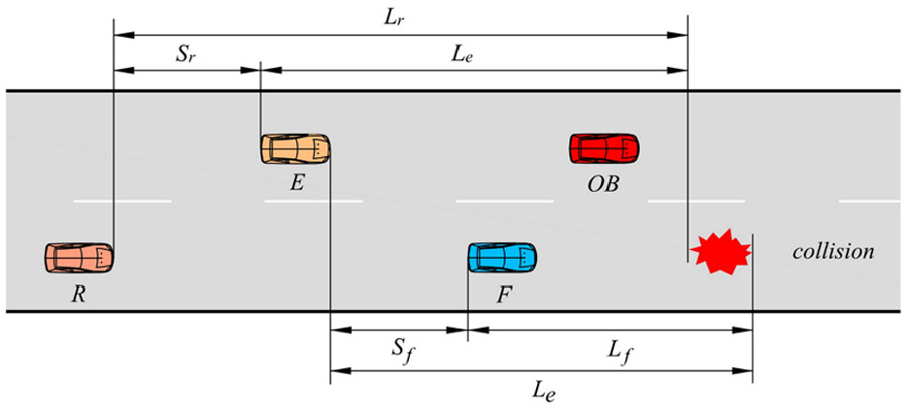

**End of Proposal**

**Thanks**